- 3 facts they have learned in the lesson
- 2 questions they have or wonder about
- 1 personal ‘a-ha’ moment – they had during the lesson or 1 key concept they identified

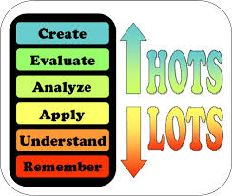 | Questions at Blooms’ levels  - 3 remember/understand  - 2 application/ evaluate  - 1 create/analyse

Questions or statements that link to a text (three level guide)
- 3 statements/questions “on the line”
- 2 statements/questions “between the line”
- 1 statement/question “beyond the line”
(AFL_1:FTT12)
- 3 things you Found out
- 2 Interesting things
- 1 Question you still have

